Director’s message

It pleases me to pen down a few sentences here. It is my privilege to confer with my teachers my students and their parents through agency of the school prospectus. Dear once I am contented to state that the student has completed its precious tenure. I love to add that all the members of the school staff have been sincerely working towards healthy academic, sports and culture milieu.

I can say it with all the satisfaction that we shall leave no stone unturned to take the school to the highest heights we shall exhaust every ounce of energy to uplift the physical and mental level of the student I hopefully say that the ensuing academic session will have better times ahead. I promise that the needy students will be given aid the brilliant students will be given extra coaching and the really hard working teachers will be honored and applauded. I wish that all concern should give us their best so that we may produce the best, do the best, and render the best.

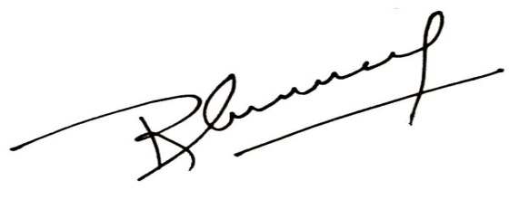

With best wishes